System Analysis of AS — AI-Powered Academic Assessment and School Platform
This document describes what I understand about your project, what it is intended to accomplish, how the software will operate, what facilities it will provide, and how each type of user will interact with the platform.
I am treating AS as the working name of your platform. I will focus on the system itself—its users, components, workflows, data, interfaces and expected behavior—not its business viability, market size or financial analysis.
Some features below describe your intended long-term system, while others are proposed for the initial version. I will distinguish between the two so that the system specification remains realistic.
SYSTEM OVERVIEW
An integrated academic platform built around continuous learning improvement
The platform connects schools, teachers and students through one digital environment. It manages academic communication and resources, supports examination assessment, uses AI to identify individual learning gaps, recommends appropriate learning resources, and creates targeted practice so students can work on their weaknesses and measure their progress over time.
The central workflow
Examination and assessment
Examination results, evaluated copies and teacher feedback
AI-powered diagnosis
Identify strengths, weaknesses and recurring learning gaps
Personalized learning
Recommend resources, explanations and targeted practice exams
Reassessment and progress tracking
Measure improvement and identify what still needs work
The cycle repeats with the student's next assessment.
1. What is the main motive of the platform?
The fundamental motive is to make examinations useful for learning improvement, not merely for generating marks.
In a conventional examination process, a student takes an exam, the teacher evaluates the answer script, and the student receives a result. Depending on the school's process, the student may see the evaluated copy or receive detailed feedback only after some delay, or may receive a mark without a clear explanation of the underlying weaknesses.
Even when a student sees the marks, several important questions can remain unanswered:
- Which particular topics does the student not understand?
- Which concepts does the student repeatedly get wrong?
- Did the student lose marks because of conceptual misunderstanding, incomplete answers or other issues?
- What should the student study next?
- How can the student practise the specific topics where they are weak?
- Did that practice actually improve their performance?
Your platform intends to connect these steps.
Instead of treating each examination as an isolated event, the software will maintain a developing picture of a student's academic performance. It will use assessment evidence to help the student understand their weaknesses, take corrective action and reassess their progress.
There is a second objective: reducing the fragmentation of academic activities. Students currently may have to use separate websites, applications or communication channels for school notices, learning materials, examination information and supplementary practice. AS intends to bring relevant academic facilities together within one school-connected platform.
The platform's two central purposes are therefore:
- Academic improvement: convert examination results and teacher-validated assessment evidence into actionable feedback and personalized practice.
- Academic connectivity: provide a shared digital environment through which schools, teachers and students can access relevant academic information and resources.
2. Who will use the system?
The platform needs different interfaces and permissions for different users. A student should not have the same permissions as a teacher, and a teacher should not have the same administrative control as the school.
A. School administrator
Primary institutional user
Manages the school's digital presence, academic structure, user access, announcements and the school's platform settings. The administrator establishes or maintains the school's classes, subjects and teacher/student relationships according to the features enabled for that school.
B. Teacher
Academic assessment and guidance
Manages the examinations and assessment records assigned to them, evaluates or verifies student work, reviews AI-generated analysis, shares learning resources and monitors student or class-level performance.
C. Student
Primary learning beneficiary
Accesses examination results and available evaluated copies, reviews specific learning gaps, receives recommended resources, takes targeted practice exams and monitors progress over time.
D. Parent or guardian
Potential supporting user
A future or optional parent-facing role could provide access to permitted progress summaries, teacher updates and learning recommendations. A dedicated parent portal and its exact permissions have not yet been established as confirmed features.
The platform should associate each user with the correct school and role. For example, a student should normally see only their own academic records, while a teacher should access only the students and classes they are authorized to manage.
E. Our dashboard:

3. How the website will be organized
The proposed platform can be organized into several connected modules. These modules may share one database and authentication system while exposing different features through role-specific dashboards.
01
School website and institutional portal
Public-facing school information, school identity, announcements and relevant academic information.
02
User and academic management
Accounts, roles, classes, subjects, teacher assignments and student enrollment.
03
Examination and assessment management
Examination records, answer-script uploads or digitization, marks and teacher validation.
04
AI assessment intelligence
Analysis of validated assessment evidence, learning-gap identification and feedback generation.
05
Personalized learning
Recommended resources, targeted practice exams, mock tests and reassessment.
06
Teacher workspace
Assessment review, AI-analysis review, resource sharing and student/class progress monitoring.
07
Student learning dashboard
Evaluated work, feedback, weak-topic reports, practice and improvement history.
08
Reporting and administration
Academic summaries, permissions, system configuration and activity records.
The first version does not need to implement every conceivable school-management feature. It should implement the core assessment-and-improvement workflow reliably, alongside the institutional and communication features required for the pilot schools.
4. Module-by-module system specification
Module 1: School website and institutional portal
Purpose
Every participating school gets a digital space connected to its academic platform. The intention is to combine relevant school information and academic interactions instead of making students depend entirely on an independent school website for one set of functions and separate applications for another.
What the school can do
The authorized school administrator can maintain information such as:
- School name, description, logo and basic institutional profile.
- Academic announcements and notices.
- Information about classes, subjects and teachers.
- Educational resources and relevant links.
- Examination-related announcements and schedules, when supported by the examination module.
- Access to the school's student and teacher platform.
How a student uses it
A student opens the school's designated portal and signs in. After authentication, the student sees the information relevant to their school and academic enrollment.
For example, the student might see a notice about an upcoming examination, resources shared by a subject teacher and a link to their assessment dashboard.
How a teacher uses it
A teacher signs in and accesses the classes, students, subjects and academic functions assigned to them. They can access relevant notices and resources without needing an entirely separate teacher-facing website.
Important system boundary
The school portal is the connectivity layer, while examination analysis and personalized learning are the platform's more specialized academic functions. Features such as fee collection, payroll, HR, attendance or full accounting are not yet established as part of the confirmed scope and should not be assumed merely because the platform is described as a school-management system.
Module 2: User accounts, roles and academic structure
Before AI can analyze a student's performance correctly, the platform must know which student took which examination, in which subject, for which class and under which teacher.
This module establishes the relationships between users and academic records.
2.1 Account creation and authentication
The platform needs a way to create and authenticate accounts. Depending on the deployment model, school administrators could invite users, or the platform could support bulk enrollment through approved student and staff lists.
A typical login flow would be:
- The user enters their login credentials.
- The system verifies the credentials.
- The system determines the user's role and school association.
- The system loads the appropriate dashboard.
- The system restricts access to records outside that user's permissions.
2.2 Academic organization
The system should represent the academic structure in a consistent way, for example:
School → Academic year → Class/grade → Section → Subject → Teacher assignment → Student enrollment
The exact hierarchy should be configurable to accommodate differences between participating schools.
2.3 Why this module matters
Suppose two students in different classes both receive a score of 60. That number alone is insufficient for a meaningful comparison. Their examinations, subjects, syllabuses, marking schemes and difficulty levels may differ.
The system needs contextual information before generating useful analysis.
Example
A student is enrolled in Class 9, Section A, and takes Mathematics with an assigned teacher. When the teacher uploads or enters an assessment, the resulting record must link to this student, the appropriate examination and the relevant subject.
That connection allows the student to see the result, the teacher to validate it, and the AI system to interpret it within the correct academic context.
Module 3: Examination and answer-script management
This module manages the examination evidence that powers the platform's main learning-improvement workflow.
It should support both the handling of digital assessment information and the digitization of physical answer scripts where required.
3.1 Creating an examination record
An authorized teacher creates an examination entry with information such as:
- Examination name and date.
- Class or participating students.
- Subject and syllabus or topic coverage.
- Total marks and, where applicable, section-wise marks.
- Associated marking scheme or evaluation criteria.
- Assigned teacher and examination status.
More detailed examination properties can be added as the product evolves.
3.2 Bringing answer scripts into the system
The platform may support several ways to capture assessment evidence.
Option A — Manual mark entry
The teacher enters the student's marks and relevant topic-wise or question-wise information. This is the simplest route for an initial MVP if scanned-script processing is not yet reliable.
Option B — Uploading a digital copy
The teacher uploads a digital answer script or another supported assessment file. The platform stores it against the correct student and examination, subject to permissions.
Option C — Scanning a physical answer script
The teacher or authorized staff member scans a physical copy and uploads the resulting file. The platform associates the scanned pages with the relevant student, examination and subject.
Option D — AI-assisted written-script evaluation
In a later or suitably validated version, the system may analyze handwritten answers using OCR, handwriting processing, language models or other evaluation components. The AI output would then be presented for teacher verification before an official result is approved.
These routes can coexist. The first version should not depend entirely on fully automated handwriting evaluation being solved.
3.3 Teacher evaluation and validation
In the initial design, the teacher remains the final authority on official marks.
A typical flow is:
- The answer script is available in the platform.
- The teacher evaluates the script or confirms the existing evaluation.
- The teacher enters or validates the marks and any required question-level information.
- The system stores the validated result.
- AI analysis can use the approved information to help identify learning gaps.
- The teacher reviews relevant AI-generated feedback or corrects it where needed.
The teacher can retain control over whether marks, comments and feedback are ready for student visibility.
3.4 What the student sees
After the teacher releases the result, the student may be able to see:
- The approved mark and examination details.
- The evaluated answer script, if uploaded and released.
- Teacher comments or corrections.
- Available AI-generated feedback.
- Topic-level strengths and weaknesses derived from the available assessment evidence.
- Recommended practice or learning resources.
The system should distinguish between an official teacher-approved result and an AI-generated suggestion so students do not confuse the two.
Module 4: AI-powered assessment intelligence
This is the central intelligence layer of AS.
Its purpose is not merely to calculate marks. It should use the information available from examinations and teacher-validated assessments to help identify where a student is struggling and what the student could do next.
4.1 Inputs to the AI system
The system could use the following information, depending on what is available:
- Examination results.
- Question-wise marks.
- Topic-wise marks or teacher-assigned topic labels.
- The question paper and marking scheme.
- Teacher-validated answer-script text or supported scanned content.
- Teacher comments and corrections.
- Previous examination results.
- Previous practice-exam results.
- Records of resources or interventions that were recommended and completed.
Not every piece of data will be available for every examination. The system must not pretend to know a student's precise misconception when the recorded evidence only shows a low overall score.
4.2 How the analysis works
Consider a hypothetical student who performs well on algebraic simplification but repeatedly loses marks in linear equations.
The system might process the available evidence as follows:
Step 1: Organize the assessment. The marks and questions are associated with the correct student, subject, examination and relevant topics.
Step 2: Identify performance patterns. The system looks for topics where marks are consistently low, mistakes recur or performance changes across assessments.
Step 3: Form a tentative diagnosis. It may flag linear equations as a possible weakness, with supporting evidence from the relevant questions.
Step 4: Generate a useful explanation. The platform explains the identified weakness in accessible language rather than merely displaying a numerical score.
Step 5: Recommend an intervention. It suggests suitable educational resources and practice questions related to the identified topic.
Step 6: Present the output appropriately. The student sees the learning recommendations, while the teacher can review the relevant analysis and correct an inaccurate interpretation.
This diagnosis should be described as a data-supported indication of where the student may need help—not as a guaranteed explanation of every mistake.
4.3 Two levels of analysis
The platform should be able to distinguish between two different kinds of analysis.
Student-level analysis
Focuses on one student's performance over time. It identifies recurring weak topics, strengths, changes in performance and possible next steps for learning.
Class-level analysis
Helps teachers identify patterns across a class, such as a topic that many students struggled with. This could help a teacher decide whether a concept should be explained again or whether extra practice is needed.
4.4 What makes the analysis useful?
An isolated statement such as “Your Mathematics score is 55%” is not enough.
A more useful system might say:
“Your performance on questions involving the formation and solution of linear equations was weaker than your performance on simplification questions. Review the worked examples on forming equations, then attempt the targeted practice set. Your next assessment will help determine whether the difficulty has improved.”
That message should be generated only when the available evidence supports it. The underlying topic classification and diagnosis need to be tested against teacher judgment before the platform relies on them at scale.
Module 5: Personalized learning resources
After identifying a likely learning gap, the platform must provide a way for the student to work on it.
This module connects diagnostic results with useful educational content.
5.1 How resources are selected
Resources might come from:
- Materials uploaded by teachers.
- Explanations and notes associated with a subject or topic.
- Approved educational resources linked by teachers.
- Question banks mapped to specific topics and difficulty levels.
- AI-generated explanations or practice material, where implemented and reviewed appropriately.
The system should associate each resource with relevant metadata, such as subject, class level, topic and intended learning objective.
5.2 Example
Suppose a student repeatedly loses marks when balancing chemical equations.
The system detects that the relevant questions are associated with that topic. It recommends a sequence:
- Review the basic principle and a worked example.
- Study a teacher-provided explanation or other appropriate resource.
- Complete a short set of basic balancing questions.
- Attempt more challenging questions.
- Take a targeted reassessment.
The student therefore receives a directed learning path rather than a generic instruction to “study Chemistry more.”
5.3 Teacher control
Teachers should be able to share relevant resources and, where the product supports it, approve or modify recommendations.
This is particularly important for school use because recommended materials should be appropriate to the class level, curriculum, syllabus and teaching approach.
Module 6: Targeted demo exams and mock tests
A key intended feature is the ability to create or assign practice examinations based on a student's identified weaknesses.
These are not simply random quizzes. Their purpose is to help the student practise specific learning objectives and then check whether the intervention has helped.
6.1 How a targeted examination is created
The system can use several inputs:
- Topics identified as possible weaknesses.
- The relevant syllabus or curriculum mapping.
- The student's previous results.
- Available questions and their topic/difficulty labels.
- Teacher-defined examination rules.
- The desired test length and difficulty.
If question generation by AI is implemented, generated questions must be checked for correctness, relevance and appropriate difficulty. The system should not assume every generated question is suitable merely because the AI produced it.
6.2 How the student takes the examination
The student opens the practice section and sees an assigned or recommended practice test.
A possible workflow is:
- Select or open the recommended practice test.
- Read the instructions.
- Answer the questions.
- Submit the responses.
- Receive the result when the answers have been evaluated according to the supported question type and review process.
- See the relevant feedback.
- Review the next recommended action.
Different question types may need different evaluation methods. For example, an objective question with a known answer can usually be scored more directly than a long written explanation requiring interpretation and partial credit.
6.3 How improvement is measured
The platform can compare the student's performance before and after targeted practice.
For example, a student scores 4 out of 10 on an initial set of questions about linear equations and then scores 8 out of 10 on a comparable reassessment.
The system can report that the student's score on that reassessment improved from 40% to 80%.
However, it should distinguish between improved performance on the practice questions and proof of long-term mastery. Stronger evidence comes from repeated performance across comparable questions and later assessments.
The cycle then continues: the system updates the student's learning record and recommends the next step where necessary.
Module 7: Student dashboard
The student dashboard is the primary interface through which the learner experiences the platform.
Its goal is to make the student's academic status and next learning steps understandable without requiring the student to interpret raw marks or technical AI reports.
The dashboard could include the following areas
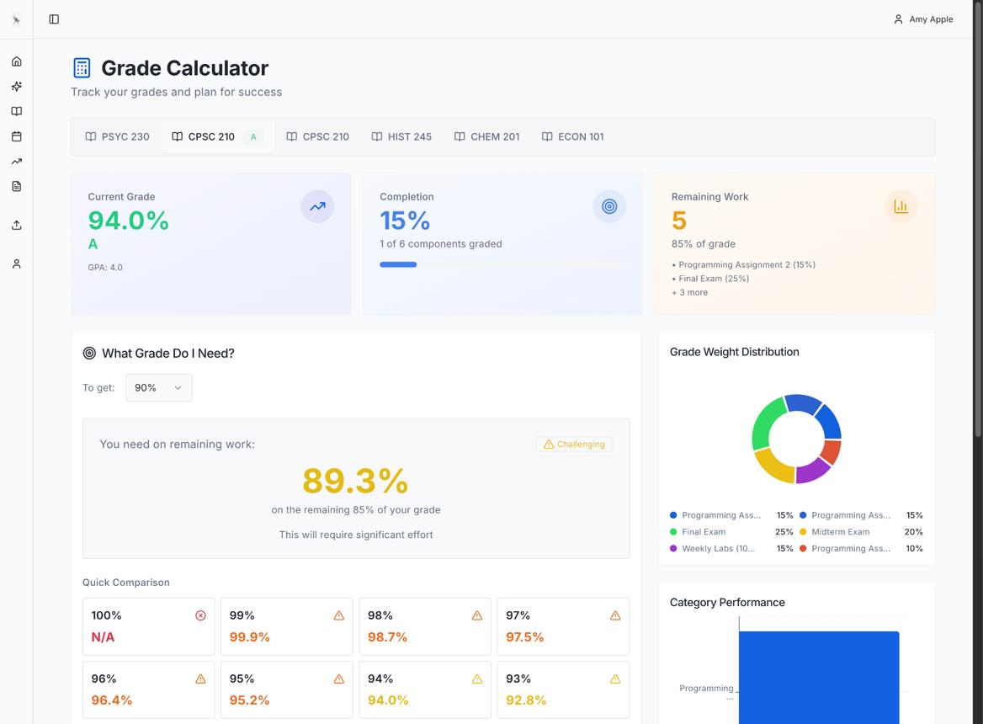
1. Academic overview
Summary of available subjects, recent assessment results, upcoming examinations and relevant school notices.
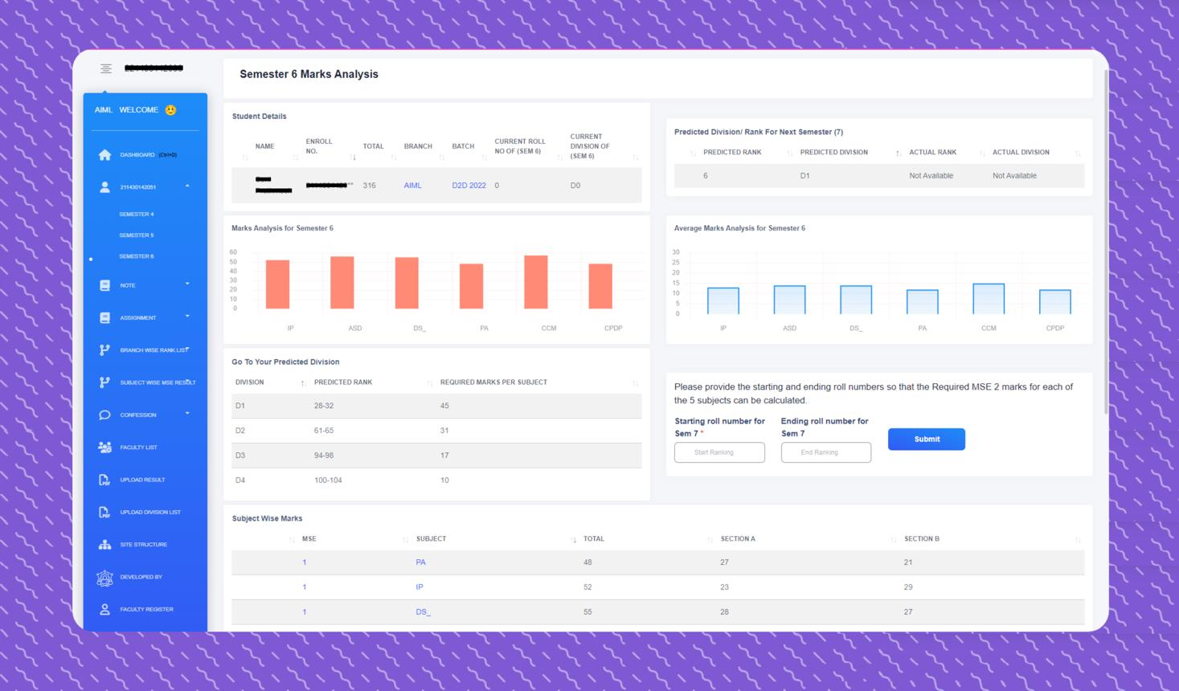
2. Examination records
Access to released results, examination history and evaluated scripts or feedback when they have been made available by the school.
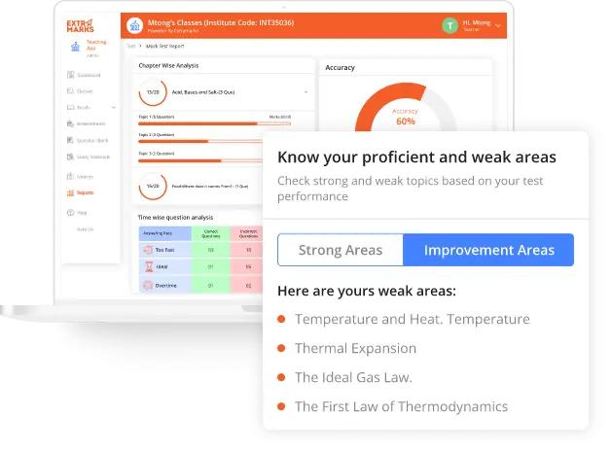
3. Learning-gap report
A clear summary of areas where the available evidence suggests the student needs additional work, together with reasons or supporting assessments where possible.
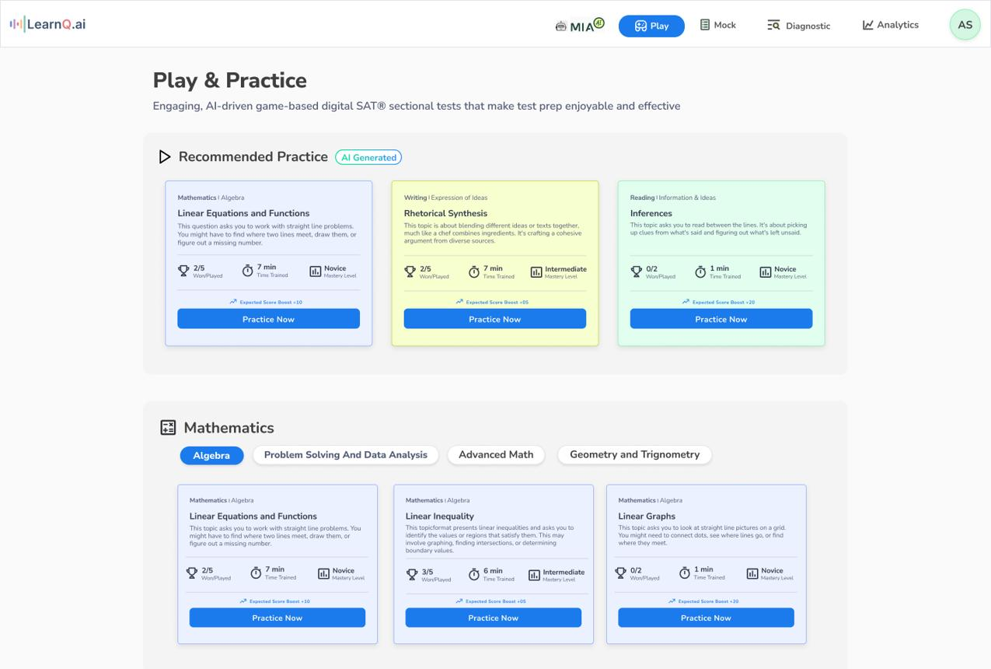
4. My learning plan
Resources, practice tests and teacher-assigned activities connected to the student's needs.
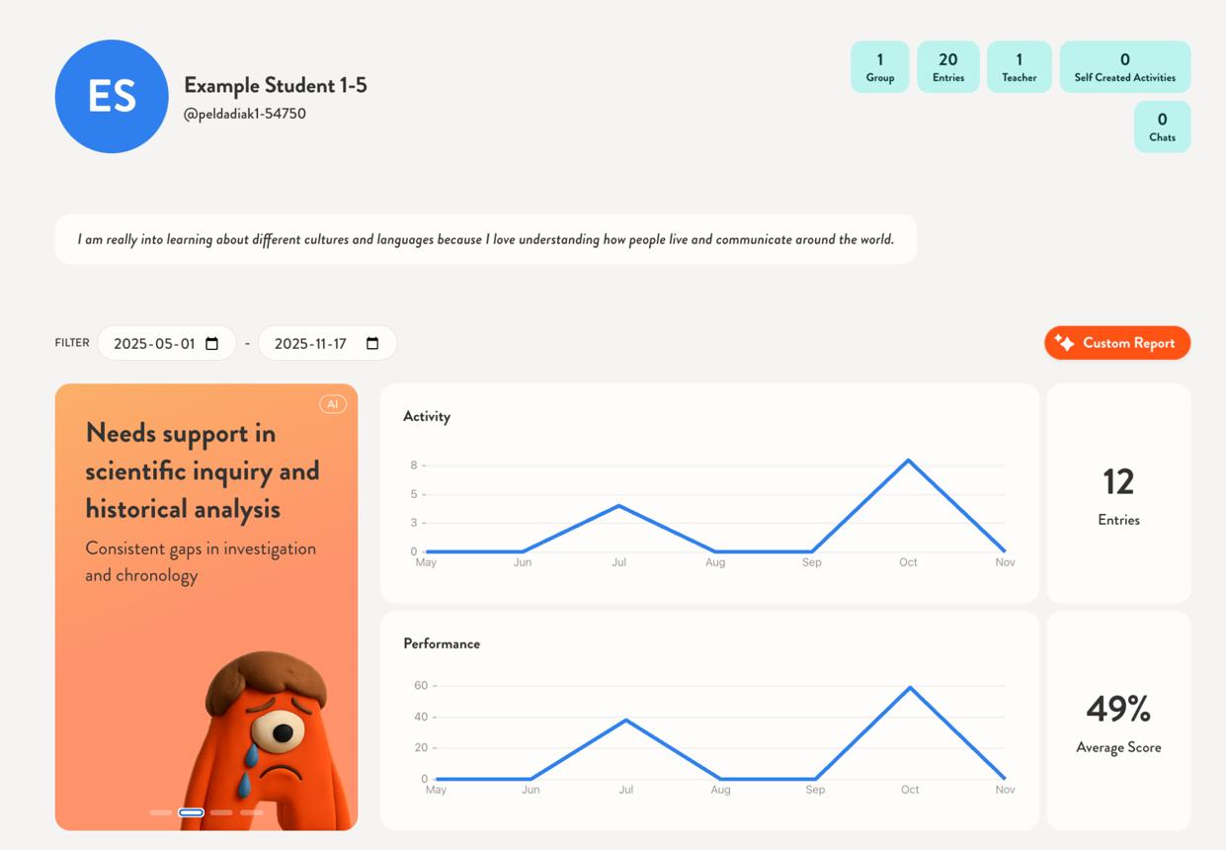
5. Progress history
Records of previous assessments and practice results, with relevant performance trends.
The specific layout and visual design can change, but the most important requirement is to connect the result, its explanation and the next action. A student should be able to move from “Where did I lose marks?” to “What should I practise next?” without navigating disconnected tools.
Module 8: Teacher dashboard
The teacher dashboard must make the platform useful within the existing academic workflow.
A teacher should not be required to hand over all academic control to an AI system or duplicate unnecessary work simply to use the platform.
Main functions
A. Class and student overview
The teacher sees the classes, subjects and students assigned to them. They can open relevant academic records without accessing unrelated school data.
B. Examination management
The teacher creates examination records, uploads or accesses answer scripts, enters marks where necessary and manages the assessment workflow.
C. Evaluation and approval
The teacher evaluates or validates marks. If AI-assisted evaluation is enabled, the teacher reviews the output and corrects it where appropriate before official marks are released.
D. AI-generated diagnosis review
The teacher views identified learning gaps and the assessment evidence behind them. The teacher may accept, edit or reject recommendations according to the workflow supported by the product.
E. Sharing educational material
The teacher shares approved learning resources, assigns practice tests and communicates relevant instructions.
F. Monitoring progress
The teacher views individual and class-level patterns to identify students who may require additional explanation or practice.
Example: a whole-class weakness
Imagine that a large proportion of students lose marks on a particular geometry topic.
The teacher dashboard could show that the topic appears repeatedly among students' learning gaps. The teacher can review the relevant questions and class results, then decide to reteach the topic or assign additional exercises.
After the next test, the teacher can see whether the students' performance on that topic has changed.
This turns the platform into a tool for teachers' academic decision-making rather than just an application that produces AI-generated feedback for students.
Module 9: School administrator dashboard
The school administrator's dashboard is responsible for the school's digital environment and the correct organization of its academic users.
The intended functions include:
- Maintaining school profile information and relevant portal content.
- Managing or coordinating user accounts and access.
- Establishing classes, sections and subjects.
- Associating teachers with the appropriate classes and subjects.
- Supporting student enrollment and academic-year organization.
- Publishing notices and relevant announcements.
- Managing platform settings permitted to the school administrator.
- Viewing permitted institutional-level reports about platform usage and academic activity.
The administrator may also coordinate examination-related processes across the school, depending on the school's chosen workflow and available permissions.
System rule: school-level reporting should show only information that the school administrator is authorized to access. Sensitive student-level information should not automatically be visible to every staff member simply because they work at the school.
5. End-to-end example: how a student receives the facilities
Consider a fictional student named Sara who takes a Mathematics examination at a participating school.
1
Examination is recorded
Sara takes the school's Mathematics examination. Her teacher creates the examination record and associates it with the appropriate class, subject and students.
2
Script is evaluated and validated
The teacher evaluates Sara's answer script and approves her result. A digital copy or scan may be linked to the record if that workflow is enabled.
3
Result is released
Sara logs in and can access the approved result and any answer-script copy or teacher feedback released to her.
4
AI analyzes the available evidence
The platform finds that Sara repeatedly struggles with forming equations from word problems. It identifies the supporting assessment evidence and presents the finding as a learning recommendation.
5
Personalized practice is offered
Sara receives relevant learning materials and a targeted practice test. Her teacher may assign or review these resources.
6
Sara takes a reassessment
After practising, Sara completes another test focused on the relevant learning objectives. The platform records her performance and compares it with the available baseline.
7
The next learning step is determined
If the evidence shows improvement, Sara can progress to more advanced questions. If the difficulty persists, the platform can recommend further practice or teacher support.
This is the intended end-to-end experience: the student is not left with a mark alone. The student is provided with a path from assessment evidence to a possible improvement, and then given another opportunity to test that improvement.
6. System architecture: what happens behind the website?
The user sees the website, but the system also needs several backend services to coordinate data, business rules and AI processing.
A practical logical architecture would contain the following layers.
Presentation layer
School portal · Student dashboard · Teacher dashboard · Admin dashboard
Application and API layer
Authentication · Permissions · Academic records · Examinations · Resources · Reporting
Data layer
Users, schools, classes, examination records, marks, resources and progress history.
AI services
Script processing where supported, weakness analysis, recommendations and practice generation.
Infrastructure and security
File storage · Cloud hosting · Backups · Logging · Monitoring · Access control
6.1 Frontend
The frontend is the part users interact with in their web browser. It provides the dashboards, forms, navigation, result views and practice interfaces.
It must make it easy to perform common tasks, especially uploading or accessing assessment information, reviewing feedback and starting a practice test.
6.2 Backend
The backend applies the system rules and coordinates data. For example, it checks whether a teacher is permitted to modify a result, whether the result has been approved, and whether a student is allowed to view the record.
The AI must not be the component responsible for deciding who has access to confidential records. That responsibility belongs to the authenticated application's permission system.
6.3 Database
The database stores the structured information required to operate the platform. Likely entities include schools, users, roles, academic years, classes, subjects, enrollments, examinations, questions, scripts, marks, resources, practice attempts and learning recommendations.
The design must preserve relationships between records. An AI-generated weakness report should be traceable to the student, subject, relevant examinations and supporting assessment data.
6.4 File storage
Examination scripts, scanned pages, uploaded documents and educational files may require separate file storage. The database can store their identifiers and metadata while the files themselves remain in appropriately secured storage.
6.5 AI processing layer
This layer performs the AI tasks and returns structured outputs to the application. It may use external APIs, internal models or a combination, depending on the implementation.
The backend should record the status of AI processing and handle failures. For example, if a scanned script cannot be processed reliably, the system should flag the problem for manual review instead of inventing a result.
7. The underlying data model
The platform's intelligence depends on preserving the academic context of its data.
A simplified conceptual model could include the following entities:
Entity | Why it exists
School | Represents the participating institution
User | Represents a student, teacher or administrator
Role and permission | Controls what a user can access or change
Academic year | Separates records from different academic periods
Class/section | Organizes students academically
Subject | Defines the subject associated with a course or assessment
Enrollment/assignment | Links students and teachers to the correct academic context
Examination | Stores examination details and status
Question and topic | Associates questions with learning objectives or syllabus topics
Answer script | Represents an uploaded, scanned or otherwise digitized answer script
Assessment result | Stores official marks and their approval status
Teacher feedback | Preserves teacher comments and corrections
AI analysis | Stores generated findings, supporting evidence and review status
Learning resource | Represents learning material associated with a topic
Practice examination | Defines a targeted or general practice test
Practice attempt | Records answers, results and completion information
Progress record | Enables comparisons across assessments and over time
Not all of these entities must become separate database tables in the first implementation. The exact design will depend on technical choices. However, these concepts need to be represented in a consistent way so that examination and learning data remain connected.
A key requirement is to preserve the distinction between:
- Raw or uploaded evidence.
- Teacher-validated results.
- AI-generated interpretations.
- Officially released results.
- Student practice outcomes.
Keeping these records distinct helps prevent an unapproved AI suggestion from overwriting an official grade.
8. How data moves through the system
Consider what happens when a teacher validates an examination result and requests an AI analysis.
- The frontend sends the teacher's action to the backend.
- The backend authenticates the teacher and checks permissions.
- The system verifies that the relevant student, examination and assessment data are correctly associated.
- The approved assessment data are passed to the AI-processing workflow.
- The AI service generates a structured analysis, such as possible weak topics and recommended next actions.
- The backend validates the output format, stores the analysis and labels its review status.
- The teacher can review or correct the analysis, depending on the workflow.
- The authorized student can see the released feedback in their dashboard.
- If practice is recommended, the system creates or assigns the relevant exercise.
- After the student submits the practice attempt, the result is saved and becomes available for later analysis.
This flow should be auditable. It should be possible to identify which assessment data supported an analysis and whether a teacher reviewed the relevant output.
9. Assessment and AI reliability requirements
Because the platform deals with school examination information, reliability is a core system requirement.
Official marks and AI suggestions must be distinct
In the initial release, the teacher remains responsible for approving official results. An AI-generated score, explanation or recommendation should carry a clear status until it has been reviewed according to the school's process.
Different questions require different evaluation techniques
Objective questions with fixed answers can often be scored using straightforward rules. Subjective written answers may require the system to interpret meaning, apply a marking scheme and assess partial credit. Handwriting, diagrams, language variation and ambiguous marking criteria add further complexity.
Therefore, the system should not present all forms of AI evaluation as equally reliable.
Evaluation should use teacher-validated reference data
The team needs a documented way to compare AI outputs with teacher-approved assessments. Depending on the task, this could measure:
- Agreement between AI-generated and teacher-approved marks.
- Error distribution and size.
- Performance by question type or subject.
- Accuracy of topic classification.
- Usefulness of feedback when reviewed by teachers.
- Frequency of outputs that require correction.
- Failure rate on unreadable or unsupported scripts.
The appropriate measures will depend on the question type. An average score difference alone may hide serious errors in individual cases.
Uncertain outputs should be handled safely
When the system cannot read a script or cannot confidently interpret a response, it should flag the result for manual review. It should not silently replace missing evidence with a guessed score.
10. Privacy, access control and record management
The platform will handle student names, academic records, examination scripts and potentially other sensitive educational information. Its architecture should protect those records from unnecessary access.
Important requirements include:
Role-based access. Students can view their own permitted records; teachers can access the classes and students assigned to them; administrators receive the access required for their duties.
Secure authentication. Accounts need appropriate authentication and session-management controls.
Protected file access. Uploaded scripts and other files should not be accessible simply by guessing or sharing a file URL.
Data minimization. The system should collect and use only the information needed for its educational functions.
Audit history. Important operations—such as changing an official mark, approving feedback or releasing results—should have appropriate records.
Data retention and deletion. The school and platform should define how long assessment files and student records are retained and how authorized deletion is handled.
Third-party AI services. If external AI services are used, the system must consider what information is sent to those services, how it is protected and whether the arrangement is appropriate for student data.
Exact retention policies, consent arrangements, school responsibilities and legal compliance requirements still need to be specified before deployment.
11. User experience and functional requirements
Beyond individual modules, the system should meet several cross-platform requirements.
Requirement | Expected system behavior
Ease of use | Teachers and students can complete common academic tasks without unnecessary complexity
Responsiveness | The website works across commonly used desktop and mobile browsers
Performance | Routine dashboard and record views respond promptly under expected load
Reliability | Assessment records and results are not lost when an AI request fails
Traceability | AI findings can be linked to the supporting data and review status
Security | Users cannot access unauthorized school or student records
Consistency | A student's result, analysis and practice history remain associated with the correct examination and topic
Accessibility | Text, navigation and feedback are readable and usable by different learners
Maintainability | Assessment, AI and school-management modules can be updated without unnecessarily disrupting the whole platform
Extensibility | New subjects, question types and learning-resource formats can be added as the system evolves
These requirements are not separate commercial features. They determine whether the product works as a dependable academic system.
12. What should be included in the initial MVP?
Your long-term vision is a comprehensive platform, but the first version should be a narrower implementation that proves the core workflow.
Initial MVP — core requirements
User accounts and roles; basic school, class and subject structure; examination records; teacher-validated marks and feedback; student results view; AI-assisted weakness analysis; educational-resource links; targeted practice tests; and basic performance history.
Early expansion
More complete script digitization, supported scanned-script workflows, improved question/topic mapping, richer teacher analytics, more sophisticated mock-exam generation and more extensive institutional portal functions.
Long-term capabilities
More advanced handwritten-answer evaluation, subject- and question-type-specific automated scoring where validated, improved longitudinal learning models, broader school integration and more comprehensive academic-management facilities.
The key architectural decision is that the platform should not need fully automated handwritten marking before it can provide value. It can begin with teacher-validated marks and assessment data, deliver diagnostic feedback and targeted practice, and add more advanced evaluation capabilities as they become reliable.
13. What the complete system is intended to accomplish
From the user's perspective, AS should behave like a connected academic environment with one main purpose: help students understand their performance and take meaningful next steps.
A student should be able to enter the platform, see the latest released result, inspect available feedback, understand the topics requiring attention, access relevant learning resources, complete targeted practice and review progress after reassessment.
A teacher should be able to manage assessment information, retain control over official evaluation, review AI-generated findings, guide students and use class-level insights to inform teaching.
A school administrator should be able to maintain the school's digital environment, coordinate academic users and make relevant institutional information accessible in one organized location.
Behind those interfaces, the platform must preserve reliable relationships between student identity, subject, examination, answer script, official marks, AI interpretations, learning resources and subsequent practice outcomes.
The defining characteristic is therefore not simply that the system uses AI or hosts a school website. It is that the assessment workflow, the diagnosis of learning gaps, the delivery of corrective learning activities and the measurement of subsequent performance are connected within the same system.
That is the system you have described building. The precise implementation can evolve, but that continuous relationship between examination evidence and a student's next learning step should remain at the center of the architecture.

